The following list reflects common data requests from city managers. Write the SQL statements to satisfy the requests. If the query can be accomplished by using different operators, sup- ply alternative solutions so that the performance-tuning group can test them and identify the more efficient statements. Test the statements and show execution results.

1. List all criminal aliases beginning with the letter B.

SELECT ALIAS

FROM ALIASES

WHERE ALIAS LIKE 'B%';

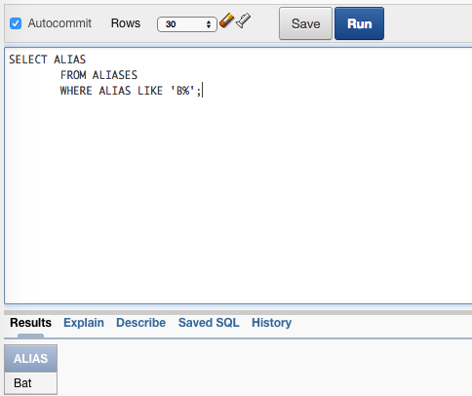

1. List all crimes that occurred (were charged) during the month October 2008. List the crime  ID, criminal ID, date charged, and classification.

SELECT CRIME_ID, CRIMINAL_ID, DATE_CHARGED, CLASSIFICATION

FROM CRIMES

WHERE DATE_CHARGED BETWEEN '01-OCT-08' AND '31-OCT-08';

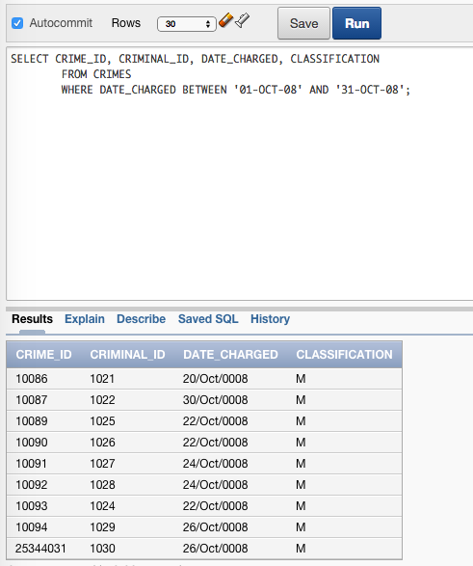

1. List all crimes with a status of CA (can appeal) or IA (in appeal). List the crime ID, criminal  ID, date charged, and status.

SELECT CRIME_ID, CRIMINAL_ID, DATE_CHARGED, STATUS

FROM CRIMES

WHERE STATUS IN ('CA','IA');

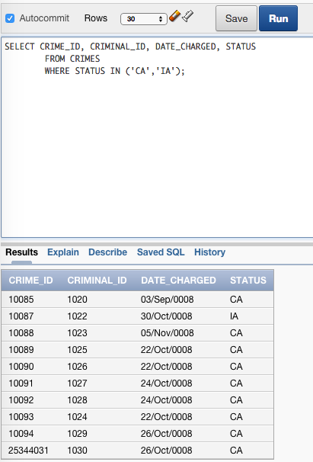

1. List all crimes classified as a felony. List the crime ID, criminal ID, date charged, and classification.

SELECT CRIME_ID, CRIMINAL_ID, DATE_CHARGED, CLASSIFICATION

FROM CRIMES

WHERE CLASSIFICATION='F';

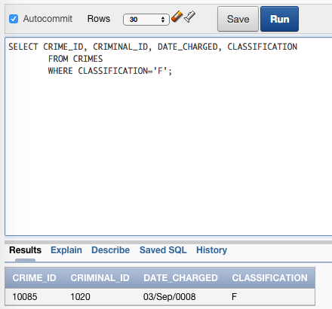

1. List all crimes with a hearing date more than 14 days after the date charged. List the crime ID, criminal ID, date charged, and hearing date.

SELECT CRIME_ID, CRIMINAL_ID, DATE_CHARGED, HEARING_DATE

FROM CRIMES

WHERE HEARING_DATE>DATE_CHARGED+14;

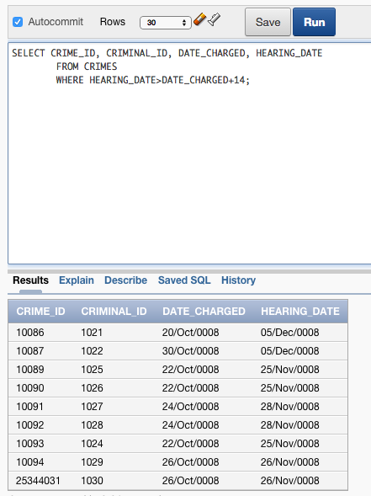

1. List all criminals with the zip code 23510. List the criminal ID, last name, and zip code. Sort the list by criminal ID.

SELECT CRIMINAL_ID, LAST, ZIP

FROM CRIMINALS

WHERE ZIP='23510'

ORDER BY CRIMINAL_ID DESC;

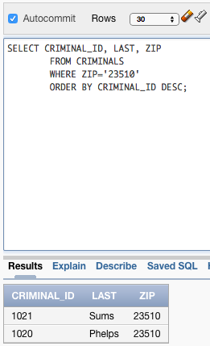

1. List all crimes that don’t have a hearing date scheduled. List the crime ID, criminal ID, date charged, and hearing date.

SELECT CRIME_ID, CRIMINAL_ID, DATE_CHARGED, HEARING_DATE

FROM CRIMES

WHERE HEARING_DATE IS NULL;

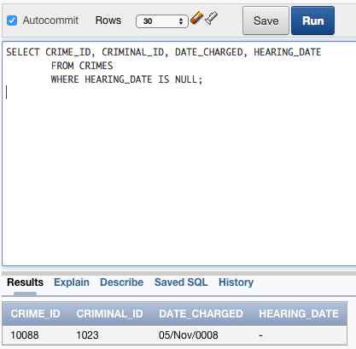

1. List all sentences with a probation officer assigned. List the sentence ID, criminal ID, and probation officer ID. Sort the list by probation officer ID and then criminal ID.

SELECT SENTENCE_ID, CRIMINAL_ID, PROB_ID

FROM SENTENCES

WHERE PROB_ID IS NOT NULL

ORDER BY PROB_ID, CRIMINAL_ID;

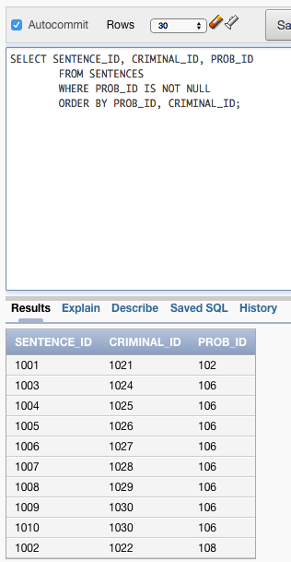

1. List all crimes that are classified as misdemeanors and are currently in appeal. List the crime ID, criminal ID, classification, and status.

SELECT CRIME_ID, CRIMINAL_ID, CLASSIFICATION, STATUS

FROM CRIMES

WHERE CLASSIFICATION='M' AND STATUS='IA';

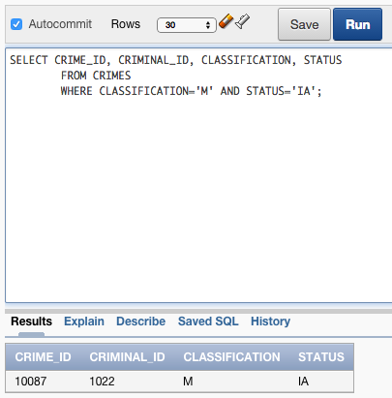

1. List all crime charges with a balance owed. List the charge ID, crime ID, fine amount, court fee, amount paid, and amount owed.

SELECT CHARGE_ID, CRIME_ID, FINE_AMOUNT, AMOUNT_PAID, (FINE_AMOUNT - AMOUNT_PAID) AS AMOUNT_OWED

FROM CRIME_CHARGES

WHERE (FINE_AMOUNT - AMOUNT_PAID)>0;

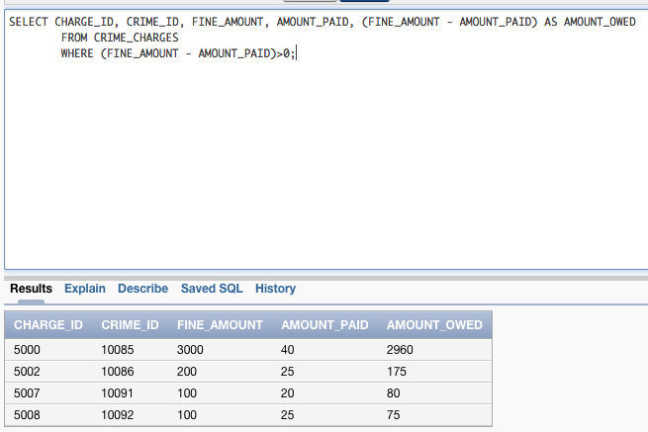

1. List all police officers who are assigned to the precinct OCVW or GHNT and have a status of active. List the officer ID, last name, precinct, and status. Sort the list by precinct and then by officer last name.

SELECT OFFICER_ID, LAST, PRECINCT, STATUS

FROM OFFICERS

WHERE PRECINCT IN ('OCVW','GHNT') AND STATUS='A'

ORDER BY PRECINCT, LAST;

